S1 Fig. Parameter estimate plots for the 19 individual participants composing the participant sample illustrated in the conjunction analysis in Figure 6 of the main text. As can be seen from these plots, there is a large degree of variability across participants, with 14/19 showing a tied>untrained main effect and 15/19 showing a clear watched > untrained main effect in right IPS (top plots), and within the right PMd ROI, we see 14/19 showing the main effect of greater activity for the tied > untrained knots, and 11/19 showing a main effect for watched > untrained knots. Looking more specifically at individual participants whose brain activity reflects the actual conjunction analysis illustrated in Fig 6 of the main text, it would appear that 13/19 demonstrate a pattern of more robust engagement within right IPS when viewing knots that had been tied compared to untrained AND knots that had been watched compared to untrained, while 9/19 demonstrate the same pattern within right PMd.

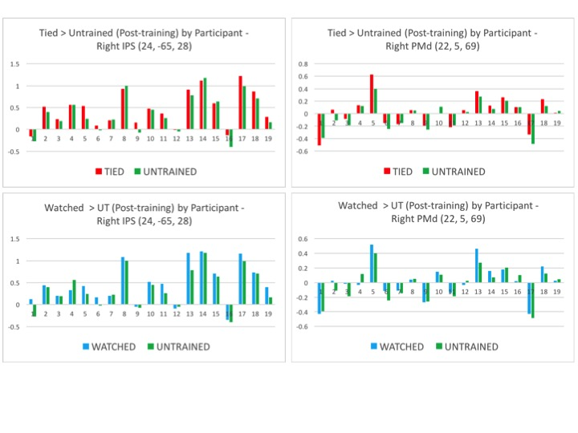

S1 Table. Whole brain analysis of the interaction between physical training experience (learn to tie > untrained knots) and scanning session. This table lists the brain regions that emerge from a whole-brain version of the (tying) training experience by scan session interaction, illustrated in Fig 5 of the main text.

Region | BA | MNI Coordinates |  |  | t-value | Cluster Size
 |  | x | y | z
(a) Post-Training Scan (Tying Experience > Untrained) > Pre-Training Scan (To-Be Tied > To-Remain Untrained)
Midline cuneus/V2 | 19 | 0 | -99 | 18 | 4.94 | 48
R fusiform gyrus | 37 | 30 | -63 | -9 | 4.60 | 176
L para-angular gyrus | 39 | -39 | -48 | 12 | 4.38 | 28
L lingual gyrus | 18 | -24 | -72 | -3 | 4.13 | 36
L superior parietal lobule | 7 | -33 | -45 | 63 | 3.65 | 28
L cerebellum |  | -33 | -87 | -33 | 3.53 | 13

